**MINI PROJECT REPORT**

On

**“COVID-19 Website”**

**Submitted for Partial Fulfilment of Award of**

**BACHELOR OF TECHNOLOGY**

**In**

**Computer Science & Engineering**



Submitted By

**NAMAN SRIVASTAVA**

**Under the Guidance of:**

**Mr. Brijesh Kumar Verma**

Assistant Professor

Dept. of CSE, BBDEC

**BABU BANARASI DAS ENGINEERING COLLEGE, LUCKNOW**

**Affiliated to**

**Dr. APJ ABDUL KALAM TECHNICAL UNIVERSITY, LUCKNOW**

**BABU BANARASI DAS ENGINEERING COLLEGE**

**Department of Computer Science & Engineering**



CERTIFICATE

Certified that the mini-project work entitled **“COVID-19 Website”** is a bonafide workcarried out by

**Student Name University Roll No**

**Naman Srivastava 2005080100053**

The report has been approved as it satisfies the academic requirements in respect of mini-project work prescribed for the course.

**Mr. Brijesh Kumar Verma Mr. Brijesh Kumar Verma Mr. Sumit Kumar Mishra**

Mini-Project Guide Mini-Project Coordinator Project Coordinator

**ACKNOWLEDGEMENT**

I express my profound gratitude to **Mr.** **Brijesh Kumar Verma**(Assistant Professor)**,** Department of Computer Science and Engineering for the valuable help and guidance in the preparation of this Report.

I would like to extend my sincere thanks to all Lab Assistants and all other staff members of B.Tech Computer Science and Engineering.

Finally, I would also wish to record my gratefulness to all my friends and classmates for their help.

**Naman Srivastava**

**2005080100053**

**DECLARATION**

I hereby declare that the Mini Project entitled **("COVID-19 Website")** is an authentic record of my own work as Mini Project for the award of degree of B.Tech. (Computer Science and Engineering), Babu Banarasi Das Engineering College, Lucknow, under the guidance of Mr. Brijesh Kumar Verma.

**Naman Srivastava**

**2005080100053**

**Date: 06-02-22**

**ABSTRACT**

The “**COVID-19 Website**” is a web-based project and maintains a repository of all the relevant information about the recent pandemic Coronavirus.

On **COVID-19 Website** a user can simply get information and latest updates about all the statistics of a country like number of cases, deaths, recovered and vaccinations.

As we can see due to Covid-19 pandemic, it has become very dangerous for all the people to go out of their homes and maintain any physical contact so physical means of communication is not preferable (like purchasing newspapers and talking with people face to face). **COVID-19 Website** provides user a simple and user-friendly interface where a user can easily access the relevant information.

The project is going to be completed with the help of HTML5, CSS and JavaScript.

**Problems in the Present System**

* User has to make physical contact for purchasing newspapers.
* User may not get proper and updated information.
* It becomes very dangerous for people if they want to go some place and may not have information about increasing virus in that area.
* It takes lot of time and effort to search for particular information.

**After implementation of the project**

* It will become easy for the user to access information of various places.
* Provide harmless system to the user.
* User can visit to the places after checking all the information easily.

**Objective**

The main objective of this project **COVID-19 Website** is to develop a robust, easy to use and secure system that provides the full updated information to the users without making physical contact.

User can decide about places they want to visit and if it not in red zone.

**Scope**

The **COVID-19 Website** has a large scope in future because:

1. It provides easy and user-friendly interface.
2. It prevents users from getting infected.
3. It saves lot of time and requires less efforts.
4. It provides relevant information to user.
5. No physical contact is required.

**Methodology**

COVID-19 Website

Tracking the change in economy due to corona

Tracking number of people get vaccinated

Tracking number of active cases

Tracking number of deaths

Tracking number of patients recovered

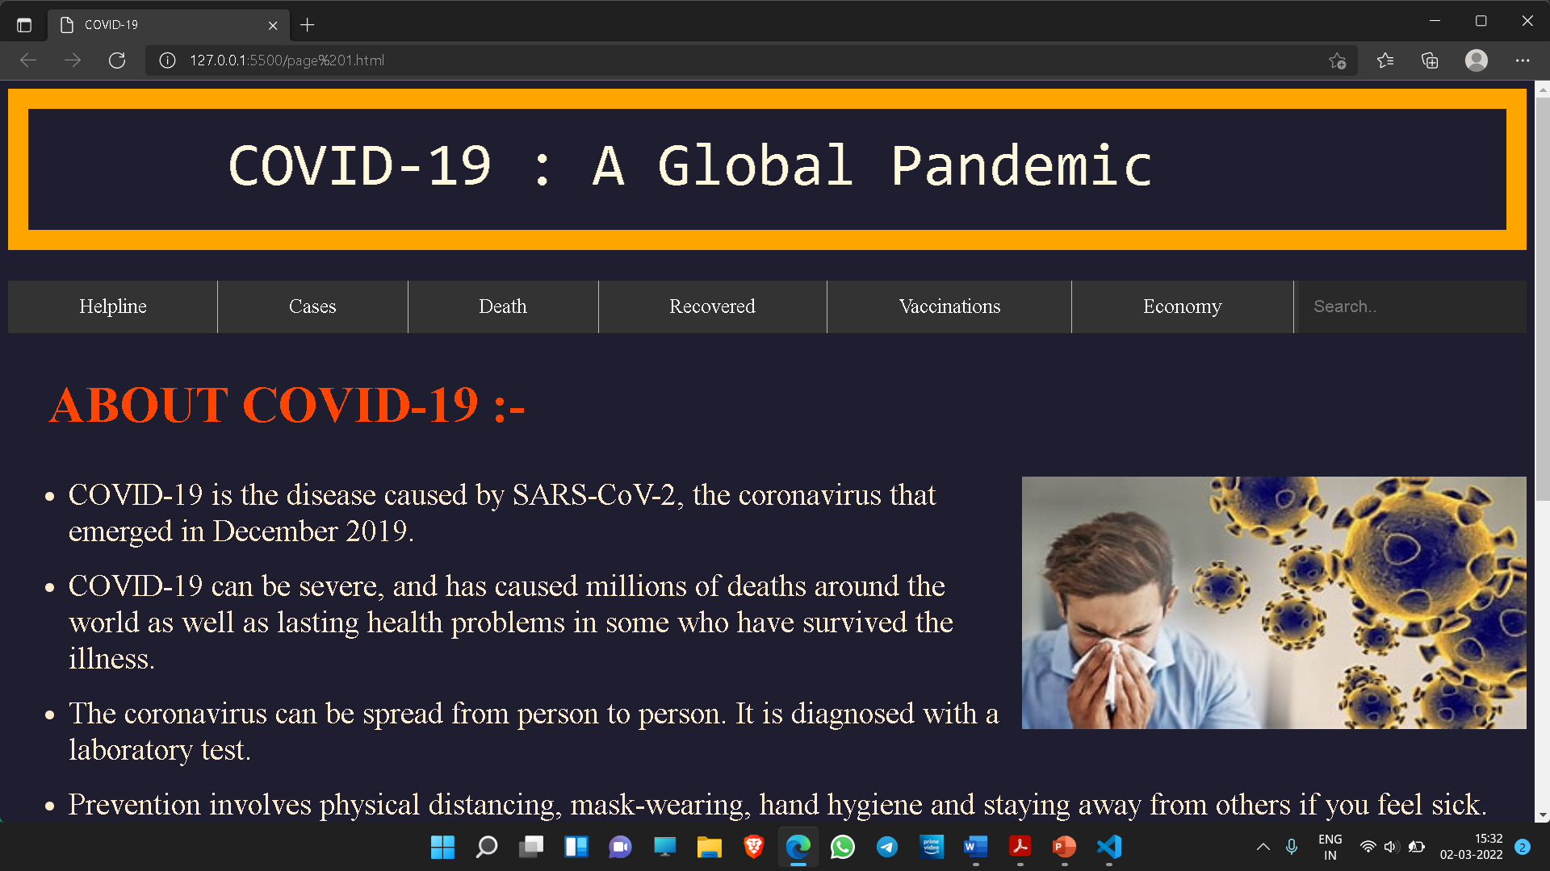 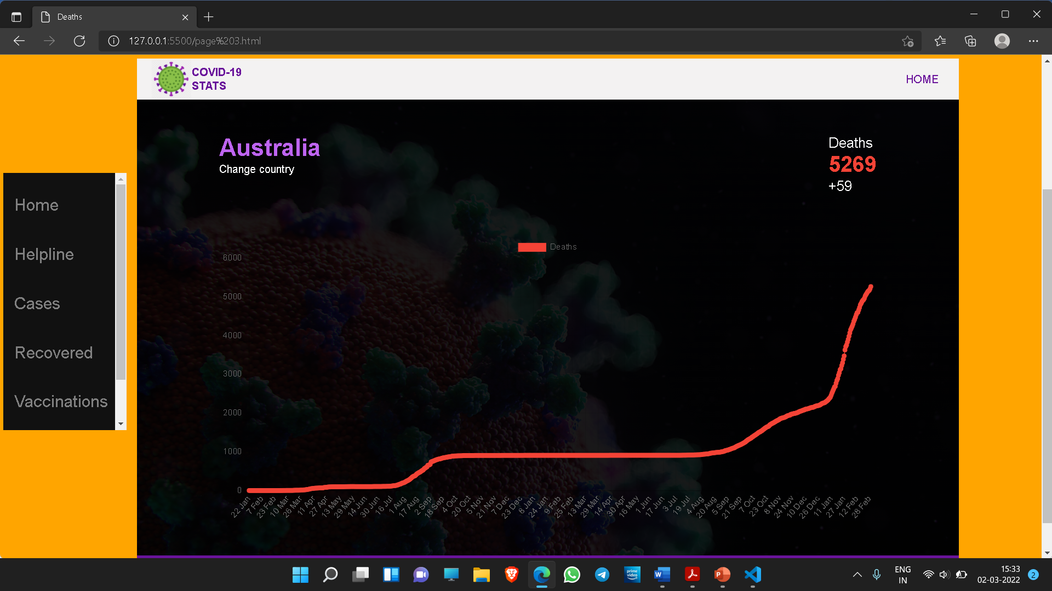

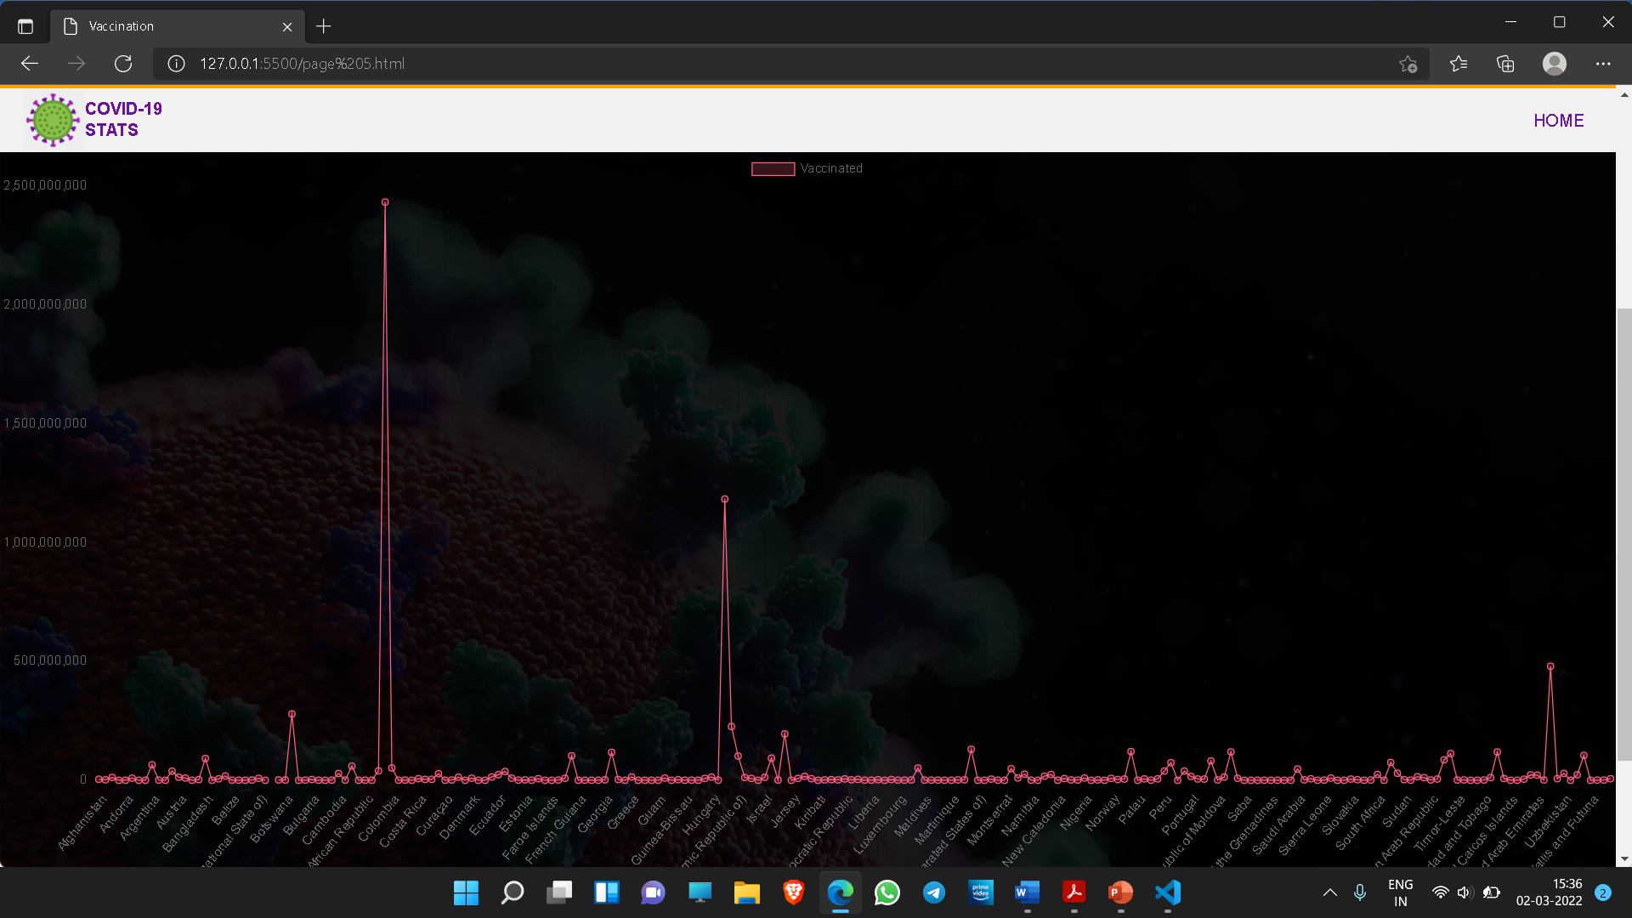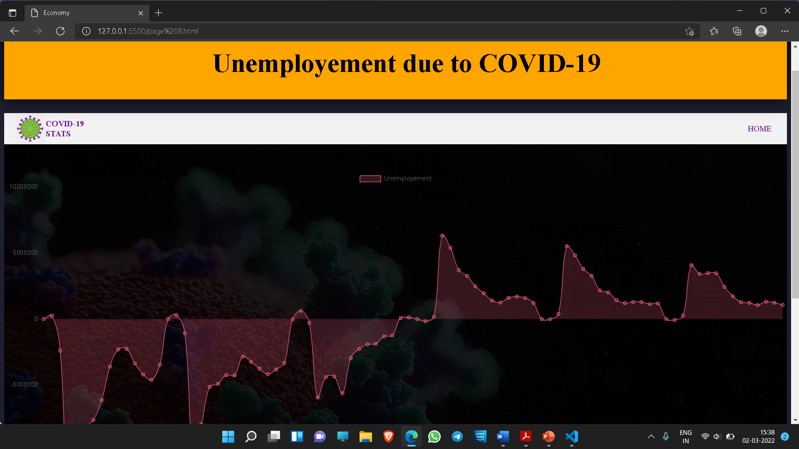

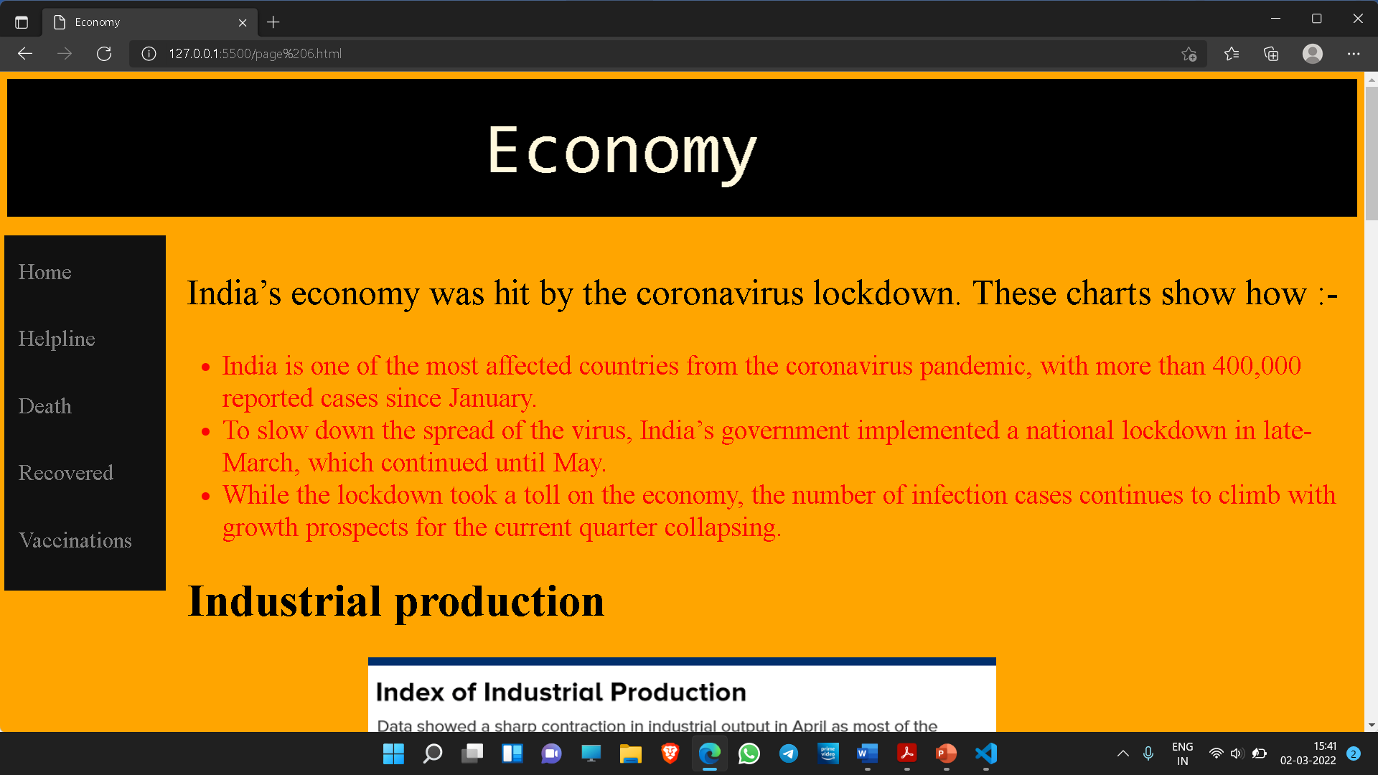

**Hardware/Software Requirements**

System Requirements:

* Minimum 1 GB RAM
* Minimum 1 GB ROM
* Stable Network

Software Requirements:

* Latest Version of Chrome/Firefox/Microsoft Edge

Technology Used:

* **HTML5**
* **CSS**
* **JavaScript**

**MODULE DESCRIPTION**

There are six modules in this project-

**MODULE-1**

It consist of **home** **page** which includes information about COVID-19 and how CORONAVIRUS started. It includes a helpline panel where anyone can find helpline numbers.

**MODULE-2**

It contains a graphical representation of **active corona cases**. The data for the graph is being fetched by an API which contains data of number of active corona cases.

**MODULE-3**

It contains a graphical representation of **deaths due to corona**. The data for the graph is being fetched by an API which contains data of number of deaths due to corona.

**MODULE-4**

It contains a graphical representation of **patients recovered**. The data for the graph is being fetched by an API which contains data of number of patients recovered.

**MODULE-5**

It contains a graphical representation of **vaccination status** of various countries. The data for the graph is being fetched by a CSV file which contains data of number of patients recovered.

**MODULE-6**

It contains a graph which shows the impact of COVID-19 on **Indian Economy.** The data for the graph is being fetched by a CSV file.

**References**

The project is implemented with the help of the following resources :

* [www.w3schools.com](http://www.w3schools.com)
* <https://www.cowin.gov.in>
* <https://www.chartjs.org>
* <https://covid19.who.int>
* You tube